EECS 448

Project 3 - Team 18

Fall 2020

**Requirement Engineering – SM Tracker**

**Name of extension**: SM Tracker (stands for Social Media Tracker)

**Description**: A browser extension tracks your social media and entertainment usage. This allows the user to set their own limits for access to those specified services.

**Features:**

- Themes: Dark Mode/Light Mode

- Use presets for websites and time limits

- Graph of internet usage based on the type of content consumed

- (Maybe) Account system so people can log in and use the extension on multiple devices

**User interface model:**  
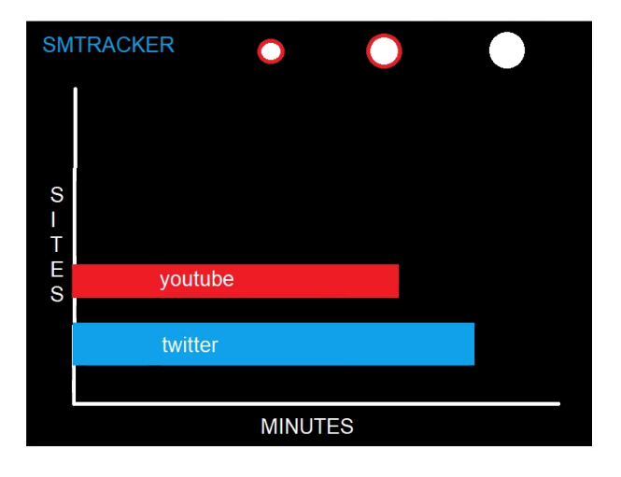

**Home:** graphing hours on social media

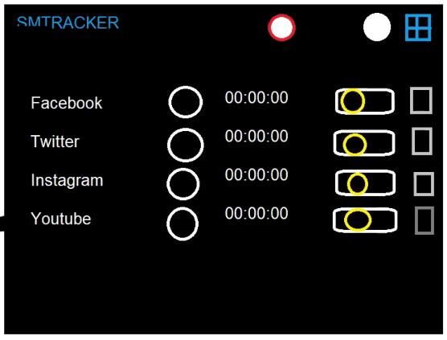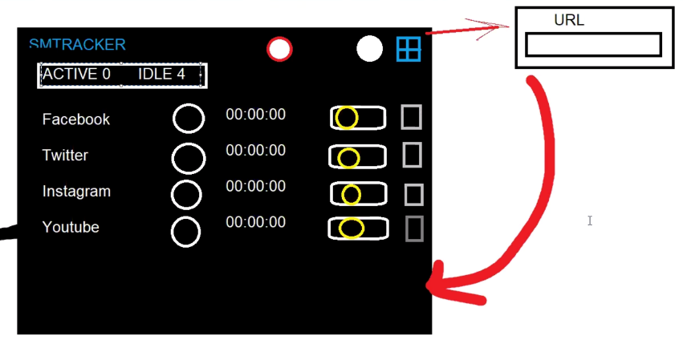

**Dashboard:** let user turn on/off tracking, add, delete

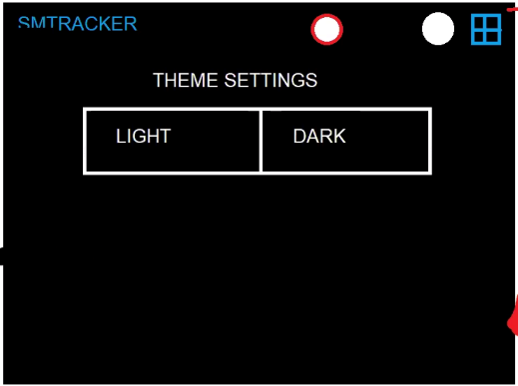  
**Settings:** Theme settings